The ideal Op Amplifier

6-1 a Main Question (สำหรับแสดงข้อสอบ)

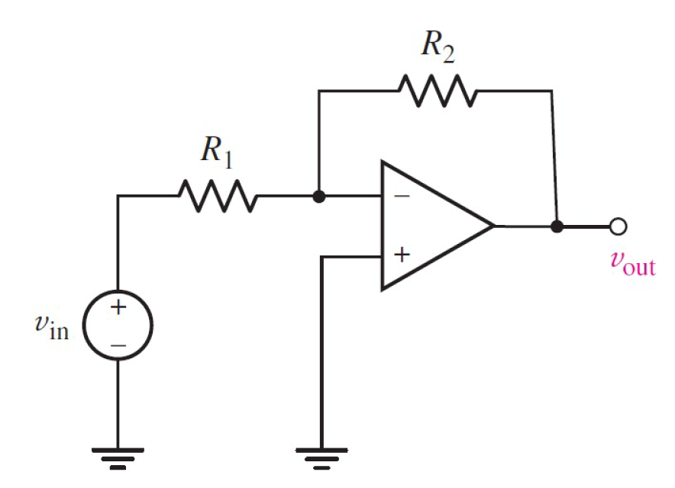

Given *V*in = 5 V,*R*1 = 100 Ω, *R*2 = 100 Ω,

Find

Variables (สำหรับเขียนโค้ดเพื่อหาคำตอบ)

Random variables

Vs = {2:10};

R1 = {100:2000:100};

R2 = {100:2000:100};

Global variables

#Vs = 5;

#R1 = 100; R2 = 100;

VOUT = -Vs*(R2/R1)

Part (กรอกคำตอบ)

1. Vout = VOUT = -5 V

6-4 a Main Question (สำหรับแสดงข้อสอบ)

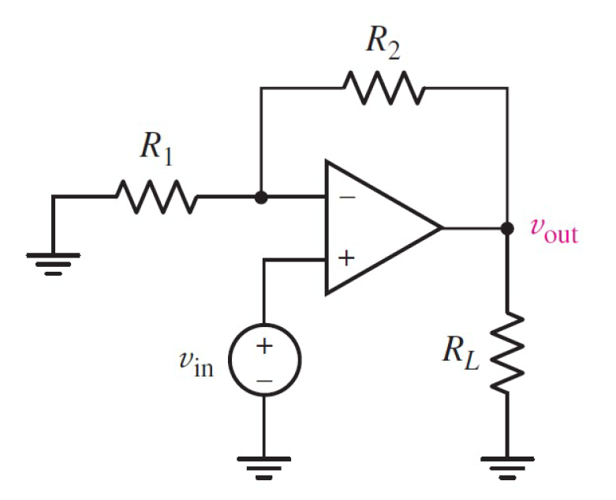

Given *V*in = 5 V,*R*1 = 100 Ω, *R*2 = 100 Ω,

Find

Variables (สำหรับเขียนโค้ดเพื่อหาคำตอบ)

Random variables

Vs = {2:10};

R1 = {100:2000:100};

R2 = {100:2000:100};

Global variables

#Vs = 5;

R1 = 100; R2 = 100;

VOUT = Vs*(1+R1/R2)

Part (กรอกคำตอบ)

1. Vout = VOUT = 10 V

6-8 a Main Question (สำหรับแสดงข้อสอบ)

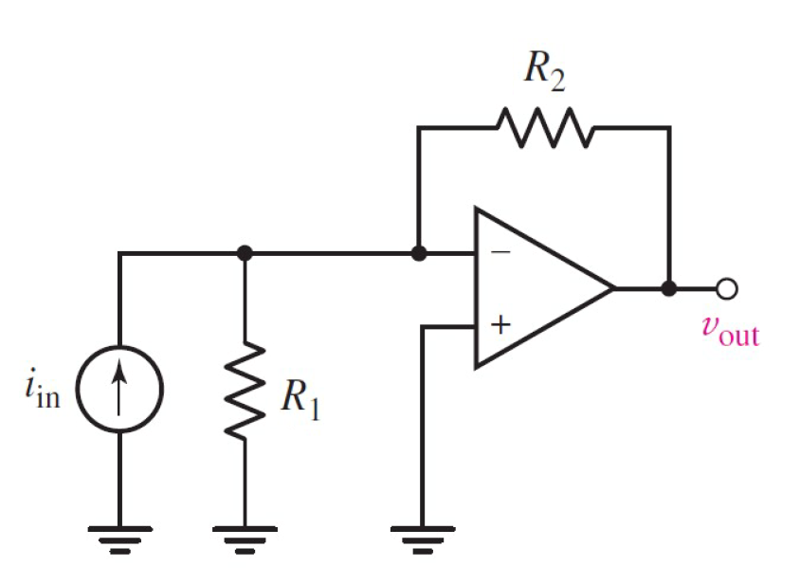

Given Iin = 3 mA,*R*1 =2200 Ω, *R*2 = 1000 Ω,

Find

Variables (สำหรับเขียนโค้ดเพื่อหาคำตอบ)

Random variables

Is = {0.002:0.010:0.001};

R1 = {100:4000:100};

R2 = {100:4000:100};

Global variables

#Is = 3;

#R1 = 2200; R2 = 1000;

VOUT = -Is*R2

Part (กรอกคำตอบ)

1. Vout = VOUT = 3 V

6-12 a Main Question (สำหรับแสดงข้อสอบ)

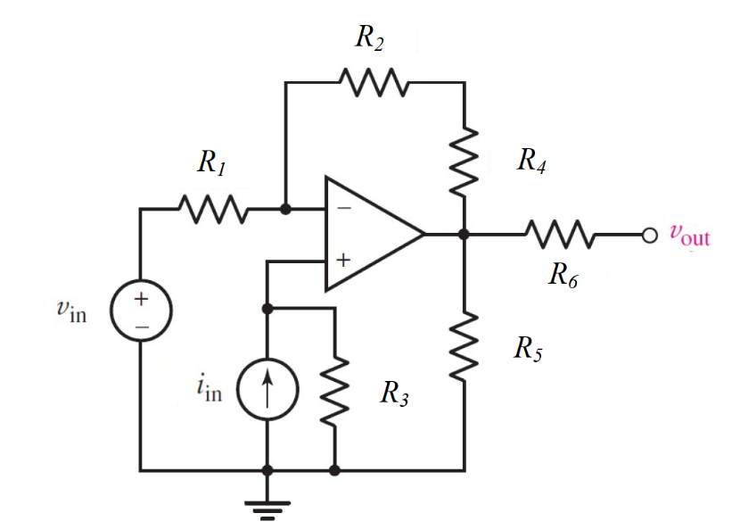

Given *V*in = 9 V, Iin = 1 mA,*R*1 =100 Ω, *R*2 = 850 Ω, *R*3 = 10000 Ω, *R*4 = 850 Ω, *R*5 = 250 Ω, *R*6 = 1 MΩ,

Find

Variables (สำหรับเขียนโค้ดเพื่อหาคำตอบ)

Random variables

Vs = {2:10};

Is = {0.002:0.010:0.001};

R1 = {100:1000:100};

R2 = {100:2000:50};

R3 = {1000:20000:10000};

R4 = {100:2000:50};

Global variables

# Vs = 9;Is = 0.001;

R1 = 100; R2 = 850; R3 = 10000; R4 = 850; R5 = 250; R6 = 1e6;

V=Is*R3;

VOUT = ((V-Vs)/R1 + V/(R2+R4))*(R2+R4);

Part (กรอกคำตอบ)

1. Vout = VOUT = 27 V

6-13 a Main Question (สำหรับแสดงข้อสอบ)

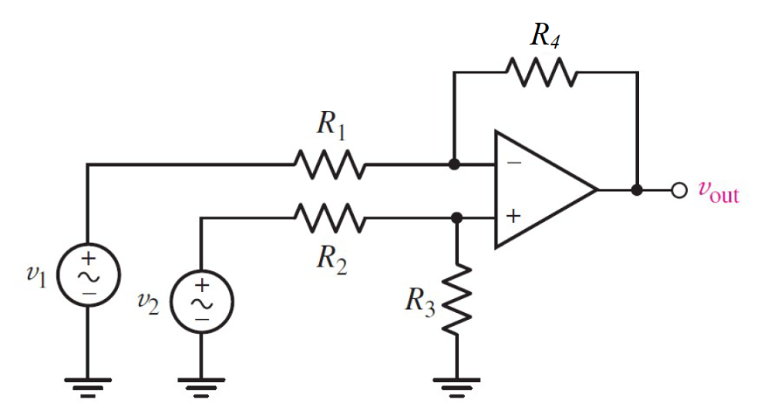

Given *V*1 = 9 V, *V*2 = 9 V,*R*1 =100 Ω, *R*2 = 850 Ω, *R*3 = 10000 Ω, *R*4 = 850 Ω, *R*5 = 250 Ω, *R*6 = 1 MΩ,

Find

Variables (สำหรับเขียนโค้ดเพื่อหาคำตอบ)

Random variables

V1 = {2:10}; V2 = {2:10};

R1 = {100:2000:100};

R2 = {100:2000:100};

R3 = {100:2000:100};

R4 = {100:2000:100};

Global variables

# V1 = 4; V2 = 3;

R1 = 1000; R2 = 800; R3 = 500; R4 = 4000;

VOUT = (1+R4/R1)*(R3/(R2+R3))*V2-(V1*(R4/R1));

Part (กรอกคำตอบ)

1. Vout = VOUT = -10.23 V